Qualitative and quantitative reservoir characterization using seismic inversion based on particle swarm optimization and genetic algorithm: A comparative case study
Ravi Kant^{1,+}, S.P. Maurya^{1,*}, and K.H. Singh^{2,+}

¹Department of Geophysics, Banaras Hindu University, Varanasi-221005
²Department of Earth Sciences, IIT Bombay, Mumbai-400076, India
*mauryasatya@bhu.ac.in
⁺these authors contributed equally to this work

ABSTRACT

Accurate reservoir characterization is necessary to effectively monitor, manage, and increase production. A seismic inversion methodology using a genetic algorithm (GA) and particle swarm optimization (PSO) technique has been devised in this study to characterize the reservoir both qualitatively and quantitatively. It has always been difficult and expensive to disclose deeper reservoirs in exploratory operations when using traditional approaches for reservoir characterization hence inversion based on advanced technique (based on GA and PSO) is proposed in this study. The main goal is to use GA and PSO to significantly lower the fitness (error) function between real seismic data and modeled synthetic data, which will allow us to estimate subsurface properties and, ultimately, accurately characterize the reservoir. Using two synthetic data and one real data from the Blackfoot field in Canada, the study examined subsurface acoustic impedance and porosity in the inter-well zone. Porosity and acoustic impedance are layer features, but seismic data is an interface property, hence these characteristics provide more useful and applicable reservoir information. The inverted results aid in the understanding of seismic data by
providing incredibly high-resolution images of the subsurface. Both the GA and the PSO algorithms deliver outstanding results for both simulated and real data. The inverted section accurately anticipated a high porosity zone (> 20%) that supported the high seismic amplitude anomaly by having a low acoustic impedance (6000-8500m/s∗ g/cc). This unusual zone is categorized as a reservoir (sand channel) and is located in the 1040–1065 ms time range. In this inversion process, after 400 iterations, the
fitness error falls from 1 to 0.88 using GA optimization, compared to 1 to 0.25 using PSO. The convergence time for GA is 670680 seconds, but the convergence time for PSO optimization is 356400 seconds, showing that the former requires 88% more time than the latter. The study recommends PSO application over GA in any E & P project because PSO inversion delivers faster convergence times, excellent error minimization, and high-resolution subsurface data compared to inversion utilizing GA optimization.

Introduction
In combined exploration and reservoir investigations, reservoir characterization from seismic data is essential because it provides very detailed geological information and characteristics of the reservoir. According to Li and Zhang¹, the oil and gas industries now extensively rely on the estimation of reservoir features using geophysical techniques for prospect appraisal, reservoir characterization, and geological modeling. When employing conventional methodologies for reservoir characterization, the problem of revealing deeper reservoirs in exploratory operations has always been challenging and expensive. A remedy for this problem has been found in coupled seismic inversion and reservoir characterization since it provides essential information about exploration and production operations. As a result, combined seismic inversion and reservoir characterization are used by the oil industry as a tool for exploration and production processes all over the world². From seismic and well-log data, subsurface petrophysical models are extracted via seismic inversion. The subsurface models can also be established using the inversion of seismic data alone in the absence of well-log data. The oil and gas business commonly uses seismic inversion techniques to identify subterranean reservoirs. The petrophysical parameters like impedance (Z), P-wave velocity (V_{s}), S-wave
velocity (V_{s}), and density (ρ) can all be calculated using seismic inversion³. The lame parameters, which are affected by fluid saturation in rocks, can also be found using inverted impedance models. The fundamental challenge with seismic inversions
is that there could be multiple solutions for a given situation. By incorporating additional information, which is frequently derived from the well-log data, the uncertainty of non-uniqueness can be reduced. Seismic inversion can be made more efficient

1

by using both local and global optimization techniques, such as simulated annealing, branch and bound, Bayesian search (partition), genetic algorithms (GAs), and others. Local optimization techniques include least-squares optimization, Pattern Search, conjugate gradient, steepest descent, quasi-Newton, and Newton⁴. A wide range of optimization techniques, such as model-based inversion, colored inversion, sparse spike inversion (SSI), band-limited inversion (BLI), etc., are used in numerous examples of reservoir characterization on post-stack seismic data and local well-log data. Post-stack seismic data was employed in this study to characterize the Blackfoot reservoir, using seismic inversion based on particle swarm optimization and genetic algorithm.
The study’s main goals are to evaluate the effectiveness of seismic inversion based purely on seismic data (PSO and GA) and to identify potentially productive zones in the Blackfoot field in Alberta, Canada. One of the bio-inspired algorithms is particle swarm optimization (PSO), which searches for the best solution in the problem space straightforwardly. It doesn’t depend on the gradient or any other differential form of the objective, in contrast to other optimization techniques, and only needs the objective function. On the other hand, the genetic algorithm (GA), which is a subset of the larger class of evolutionary algorithms (EA), is a metaheuristic used in computer science and operations research that draws inspiration from the process of natural selection⁵. When solving optimization and search issues, genetic algorithms commonly use biologically inspired operators like mutation, crossover, and selection. Since layer information at well sites is extended across the seismic volume, it is typically used for reservoir characterization and petrophysical study. This enables accurate subsurface geology to be defined. Global optimization techniques (PSO and GA) are used in seismic inversion to overcome the problem of solutions getting trapped within local minima³. This is accomplished by determining the model’s (objective function’s) least feasible mismatch with the seismic data. Because the observed seismic data may be thought of as a forward model in which the seismic wavelet is convolved with the earth’s reflectivity series, the inversion process is model-driven. This process can be described by stochastic or deterministic methods. With no information loss, these techniques can generate quantifiable genuine model parameters of subsurface rock attributes (earth models), such as impedance, porosity, compressional velocity (V_{P}), and reflectivity, resulting in a practical global optimum solution. These methods help to improve thin-bed stratigraphy recovery, volumetric estimation, wavelet effects removal, sand body quantitative characterization, tuning problems, and seismic data de-noising, in general,⁶. The results of global inversion procedures can lead to greater resolvability and a more favorable correlation between seismic data and lithology. Using post-stack seismic data from Blackfoot, Canada, we compare the robustness and computing effectiveness of two model-driven global optimization algorithms, the genetic algorithm (GA) and particle swarm optimization (PSO).
The post-stack seismic data along with well log data is used from the Blackfoot field, Alberta, Canada. In the Canadian province of Alberta, Blackfoot Field is situated southeast of Strathmore City. In order to better understand the clastic Beaver Hill Lake carbonates and the reef-prone Glauconitic channel, the data was gathered in two overlapping patches⁷. 708 shots (seismic source), distributed across 690 fixed recording channels, make up the collection⁸. The data has a vertical bandwidth of 5–90 Hz and a horizontal bandwidth of 5–50 Hz. Data from the first patch i.e. reef-prone Glauconitic channel is used in this study. Simin⁹ provides a detailed description of the processing techniques applied to the vertical and horizontal component data.

Methodology

Genetic Algorithm
Holland (1975) developed genetic algorithms (GAs), which were the first global optimization techniques used in this investiga-tion. The more prevalent category of evolutionary algorithms includes genetic algorithms (GAs), which are adaptive heuristic search engines. On the concepts of natural selection and genetics, genetic algorithms are built. Natural selection, the mechanism that propels biological evolution, is the foundation of the genetic algorithm, which resolves both constrained and unconstrained optimization issues. GA works by repeatedly changing each unique solution in a population. The genetic algorithm chooses at random each unique solution, known as a parent, and utilizes it to create a new solution, known as children. After a significant number of generations, the problem’s solution approaches the optimum¹⁰. The evolutionary algorithm is used in many study domains to optimize discontinuous, non-differentiable, stochastic, or highly nonlinear conditions by decreasing errors between observed and modeled data. In this study, a genetic algorithm is employed to determine the subsurface acoustic impedance and porosity by minimizing the discrepancy between the observed and modeled seismic traces. To build a new population from the present population, the genetic algorithm performs three main processes, selection, crossover, and mutation¹¹.
Using a selection technique based on fitness scores, individual models are coupled. Whether or not they are selected depends on the model’s fitness value. The likelihood of selecting a model with very high fitness values is much higher than that of selecting a model with low fitness values. This is due to the fact that more often the models that suit the data will be chosen for replication. The model’s fitness value determines the selection probability¹². The crossover genetic operator is applied after the models have been chosen and coupled. Transferring genetic data between paired models is the basic tenet of a crossover. The crossover could also be seen as a means of information sharing between paired models, leading to the creation of new models¹³. Geophysical difficulties might involve either single-point crossover or multipoint crossover. The fundamental

idea behind the single-point crossover is the use of a uniform probability distribution to choose the model’s one-bit location at random. The right side of the selected bit is then exchanged between two models, resulting in the creation of a new model. On the other hand, the multipoint crossover method randomly chooses a bit location and then shifts all bits up to this bit throughout the matched models. A further bit location is chosen at random from the second model parameter, and any bits that immediately follow this bit are again exchanged. Every model parameter goes through this process¹⁴.
The mutation, which adds randomization to the crossover, is adopted in the final stage. The mutation process often happens during the crossover phase. The mutation rate, which is determined by a probability chosen by the method’s creator, controls how many walks there are in the model space. Because there won’t be many walks in the model space due to the low mutation frequency, the problem will be transformed shortly. On the other hand, the high mutation probability will result in a lot of space-based random walks, but this can delay the algorithm’s convergence¹⁵. In the process of mutation, one new solution (children) from the crossing is chosen and employed as a parent. In order to produce unpredictability in the result, two mutation sites are selected and switched between one another.

Particle Swarm Optimization
The foraging and social activities of the swarm serve as the inspiration for particle swarm optimization (PSO). PSO imitate the action or the phenomenon, such as a bird flock or a school of fish. The algorithm of PSO was developed by Eberhart and Kennely in 1995¹⁶. The PSO is used to optimize continuous non-linear function by direct search approach and does not need any gradient information like other optimization needed. The benefit of not using gradient information is that, it can be used for discontinuous function. PSO begins with a randomly initialised population, much like a genetic algorithm (GA). Solutions, unlike GA operators, are given randomised velocities to explore the search space. In PSO, a particle is a solution of any kind. Three distinct features of PSO are given below.
- p_{best} _{i} : the best outcome (fitness) that particle i has so far attained
- g_{best}: the most effective outcome (fitness) that any swarm particle has yet attained.
- For exploring and utilising the search space to find the best answer, use velocity and position updates.
Now we will start with the position update first because it will behave like a variation operator that will help to change the current position of a particle to its position.
x_{id}(t + 1) = x_{id}(t) + v_{id}(t + 1) f or 1 ≤ i ≤ m and 1 ≤ d ≤ n (1) The following updates to particle (i) velocity are made.
v_{id}(t + 1) = wv_{id}(t) + c₁r₁(p_{id}(t) − x_{id}(t)) + c₂r₂(g_{id}(t) − x_{id}(t)) (2)
Where w is an inertial weighting factor that linearly decreases with the number of iterations to give the algorithm strong global search performance at the beginning and strong local search performance at the end. The numbers c₁ and c₂, also known as learning factors or acceleration factors, are positive constants. The particle’s step length to reach its current best position is controlled by c₁, while the particle’s step length to reach the world’s best position is controlled by c₂. Kennedy in (2003)¹⁷ conducted a number of parameter experiments and found that when the algorithm behaves better, the sum of c₁ and c₂ should be around 4.0. The random values r₁ and ₂ fall between [0, 1], while t is the iteration number. In order to prevent particle velocities that are insufficient for a particle to fly over the ideal position, the maximum speed of particles must be limited. We
refer to each particle’s top speed as having a maximum of V_{max}, and if V_{max} < v_{id} , we set V_{max} = v_{id}; if V_{max} > v_{id}, we set
−V_{max} = v_{id}¹⁸. The particle’s initial positions and speeds are produced at random, and the above two equations are iterated until a workable solution is obtained. Equation 2 involves three components,
- Momentum part (wv_{id}(t)) : the first component is the particle’s earlier velocity, which guarantees the particle’s flight.
- Congnitive part c₁r₁(p_{id}(t) − x_{id}(t)) the second component is a vector that points from the particle’s present position to its own best position.
- Social part c₂r₂(g_{id}(t) − x_{id}(t)) : final component is a vector from its current location to the swarm’s best position¹⁹.
Each particle adjusted its speed in accordance with Eq.(1) throughout each iteration. Fly to the new position in accordance to Eq. (2)²⁰.

Algorithm Test

1D Synthetic model
The approach is used to estimate acoustic impedance on a synthetic trace, and synthetic seismograms are built to verify the method. For this, an acoustic impedance-based seventeen-layer Earth model is used with a range of AI is 7040m/s ∗ g/cc, 9065m/s ∗ g/cc, 5740m/s ∗ g/cc, 7425m/s ∗ g/cc, 10040m/s ∗ g/cc, 8225m/s ∗ g/cc, 9500m/s ∗ g/cc, 11700m/s ∗ g/cc, 6300m/s ∗ g/cc,10455m/s ∗ g/cc, 7425m/s ∗ g/cc, 13500m/s ∗ g/cc, 11700m/s ∗ g/cc, 10000m/s ∗ g/cc, 14144m/s ∗ g/cc, 15568m/s ∗ g/cc, 12720m/s ∗ g/cc. We employed genetic algorithms and particle swarm optimization approaches to minimize the error between observed and simulated data after creating synthetic data sets.
The resulting 1-D post-stack seismic data were inverted to get the impedance values for each layer. This study uses a forward model for a 17-layered scenario. Each layer was thought to be homogeneous, with uniform velocity and density throughout. Each layer’s depth, velocity, and density were all model parameters. After that, the same model was inverted using GA and PSO, and model parameters were computed. The error function that was utilized for minimization is shown below.
(3)

∑n
Error = W₁
i=1
∑n |Sob j i|
|Sob j i − Smod i|!
i=1

∑n
+ W₂
i=1
∑n |Zob j i|
|Zob j i − Zmod i|!
i=1

Where Error is the difference between model and observation, S_{mod} _{i} is modeled data at the ith sample, S_{ob} _{ji} is observed data at the ith sample, and Z_{mod} _{i} is the modeled impedance at ith time sample n is the total number of sample points in the data and Z_{ob} _{ji} is the observed impedance at ith sample. W₁ and W₂ are weights applied to the two terms, respectively. In most of the cases, these weights are chosen as unity i.e. W₁ = W₂ = 1. The related results are presented in Figure 5. Tracks 1 and 2 of Fig. 1 illustrate the velocity and density of the subsurface geology model, whereas tracks 3 show the comparison of original
impedance and predicted impedances from the genetic method and particle swarm optimization, respectively. By minimizing the error from eq. (3), the best outcomes are estimated. The calculated P-impedances agree well with their real models, and the correlation coefficients for GA and PSO are estimated to be 0.99 and 0.99, respectively. Figure 1, tracks 4 and 5 compare synthetic traces from modeled impedance and reproduced synthetic traces from inverted impedance estimated from GA and PSO show a very close match with each other with 0.99 and 0.98 correlation respectively.
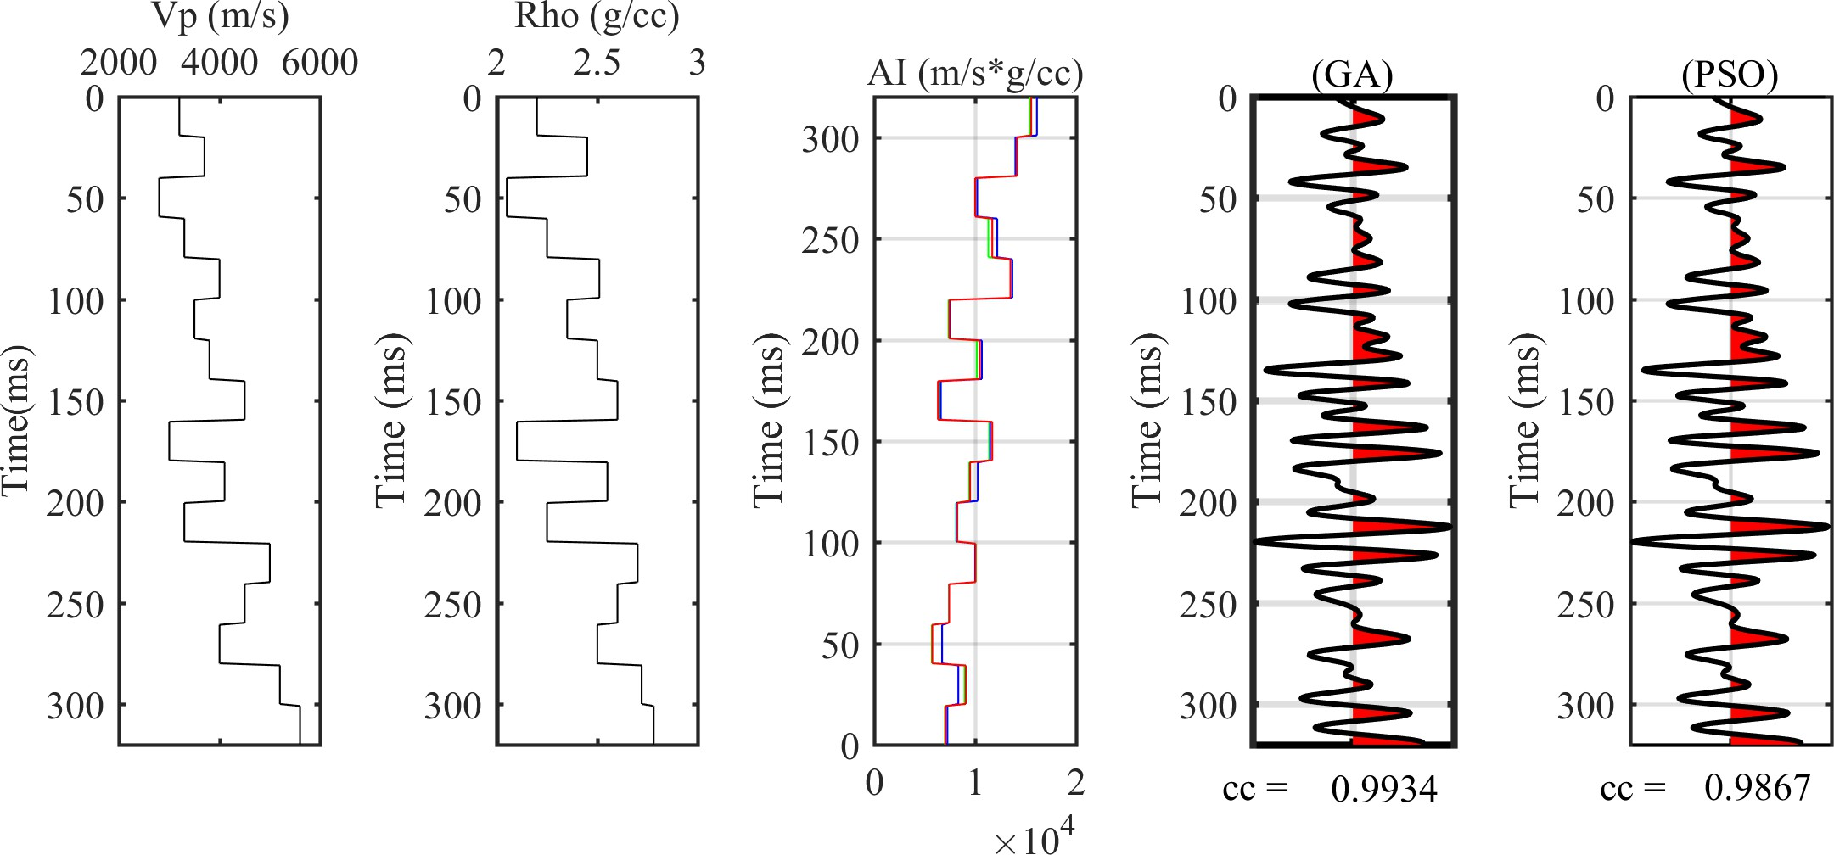

Figure 1. Show the results of the 1D convolution model using synthetic data and seismic inversion.

As a quality check of inverted data, a cross plot between inverted and original impedance is constructed and exhibited in Fig. 2. The image of track one depicts the best-fit line as a solid blue line, and the red and blue circle show inverted impedance which is the outcome of applying GA and PSO algorithms. From this figure, we see that the circles are to close the best-fitting line. The proximity of the scatter points to the best-fit line indicates that the inverted results are extremely near to the true value, confirming the algorithm’s effectiveness. Table 1 compares observed and modeled impedance for each individual layer estimated by genetic algorithms and particle swarm optimization. Figure 2b depicts error analysis for the genetic method (top) and particle swarm optimization (bottom). In the entire process of inversion, PSO takes 34 sec and GA takes 54 sec to archive

the optimal solution. According to the observations and numerical analysis, the PSO produces better outcomes than the GA approaches.

Layers | V_{p}  (m/s) | ρ  (g/cc) | AI original  (m/s*g/cc) | AI inverted (GA)  (m/s*g/cc) (error %) | AI inverted (PSO)  (m/s*g/cc) (error %)
Layer 1 | 3200 | 2.2 | 7040 | 6995 (0.6) | 7244 (2.9)
Layer 2 | 3700 | 2.45 | 9065 | 8948 (1.3) | 8328 (8.1)
Layer 3 | 2800 | 2.05 | 5740 | 5691 (0.9) | 6716 (17.0)
Layer 4 | 3300 | 2.25 | 7425 | 7399 (0.4) | 7416 (0.1)
Layer 5 | 4000 | 2.51 | 10040 | 10064 (0.2) | 9998 (0.4)
Layer 6 | 3500 | 2.35 | 8225 | 8099 (1.5) | 8143 (1.0)
Layer 7 | 3800 | 2.50 | 9500 | 9406 (1.0) | 10270 (8.1)
Layer 8 | 4500 | 2.6 | 11700 | 11391 (2.6) | 11495 (1.8)
Layer 9 | 3000 | 2.1 | 6300 | 6541 (3.8) | 6586 (4.5)
Layer 10 | 4100 | 2.55 | 10455 | 10159 (2.8) | 10668 (2.0)
Layer 11 | 3300 | 2.25 | 7425 | 7351 (1.0) | 7466 (0.6)
Layer 12 | 5000 | 2.7 | 13500 | 13702 (1.5) | 13697 (1.5)
Layer 13 | 4500 | 2.6 | 11700 | 11305 (3.4) | 12195 (4.2)
Layer 14 | 4000 | 2.5 | 10000 | 10199 (2.0) | 10208 (2.1)
Layer 15 | 5200 | 2.72 | 14144 | 14065 (0.6) | 14001 (1.0)
Layer 16 | 5600 | 2.78 | 15568 | 15400 (1.1) | 16138 (3.7)
Layer 17 | 4800 | 2.65 | 12720 | 12666 (0.4) | 12911 (1.5)
Table 1. Observed and modeled AI for synthetic data case comparison.

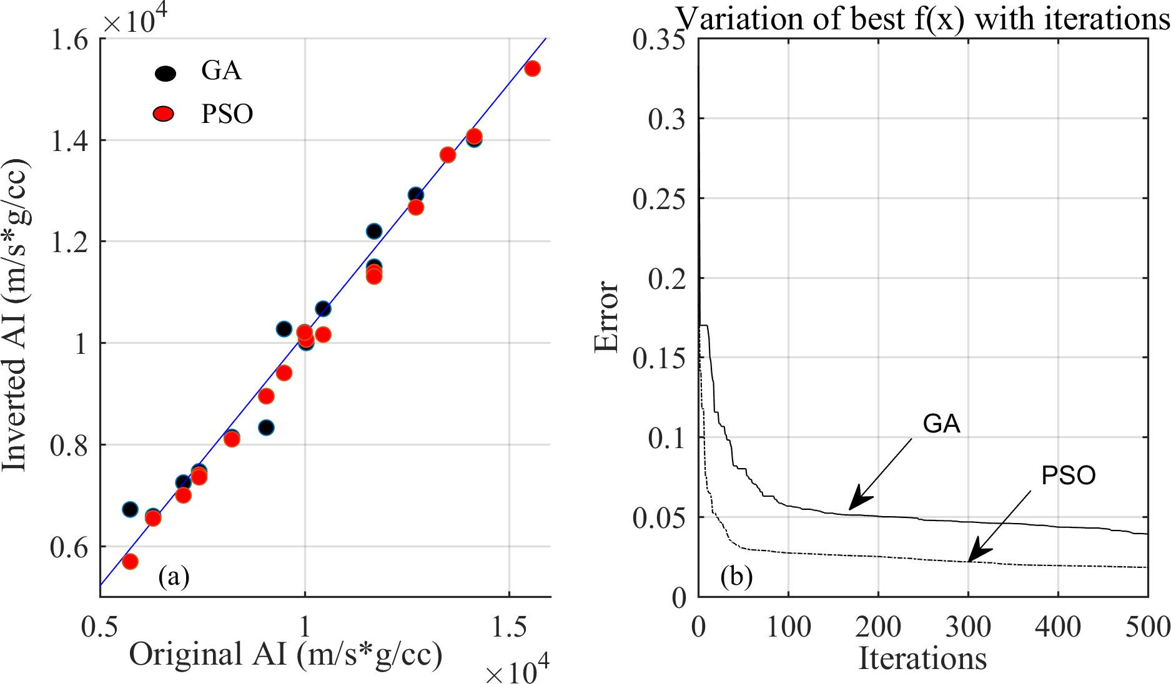
Figure 2. (a) Displays a cross plot of the modeled and actual impedance, and (b) for the inversion of synthetic data, it displays the variation in error with iteration.

Synthetic Wedge Model
The wedge model is a key component of the interpreter’s toolkit for coal seams. It is widely used to comprehend the geologic significance of seismic amplitudes below a reservoir’s tuning thickness. Tuning describes the modification of seismic amplitudes brought on by beneficial and harmful interference from overlapping seismic reflections. When numerous closely spaced contacts

reflect a downward wave, this occurs. If the resulting upgoing reflections coincide, the reflected seismic energy will interact with and change the amplitude response of the true geology.
Let’s look at this using a Matlab-built zero-offset synthetic wedge model (Fig. 3). Linearly, the seam thickness rises from 70 to 90 m. We can observe that the wedge’s amplitude response is constant. This shows that the top and bottom of the wedge have distinct reflections with no interference. Figures 3a and 3b depict a theoretical wedge model of a pitchout coal seam and a forward seismic profile based on the convolution model. Figures 3c and 3d show the impedance section estimated using a genetic algorithm and particle swarm optimization method respectively recognizing two distinct events that are thinner than the tuning thickness. The analysis demonstrates that the PSO estimates superior resolution than the genetic algorithms.
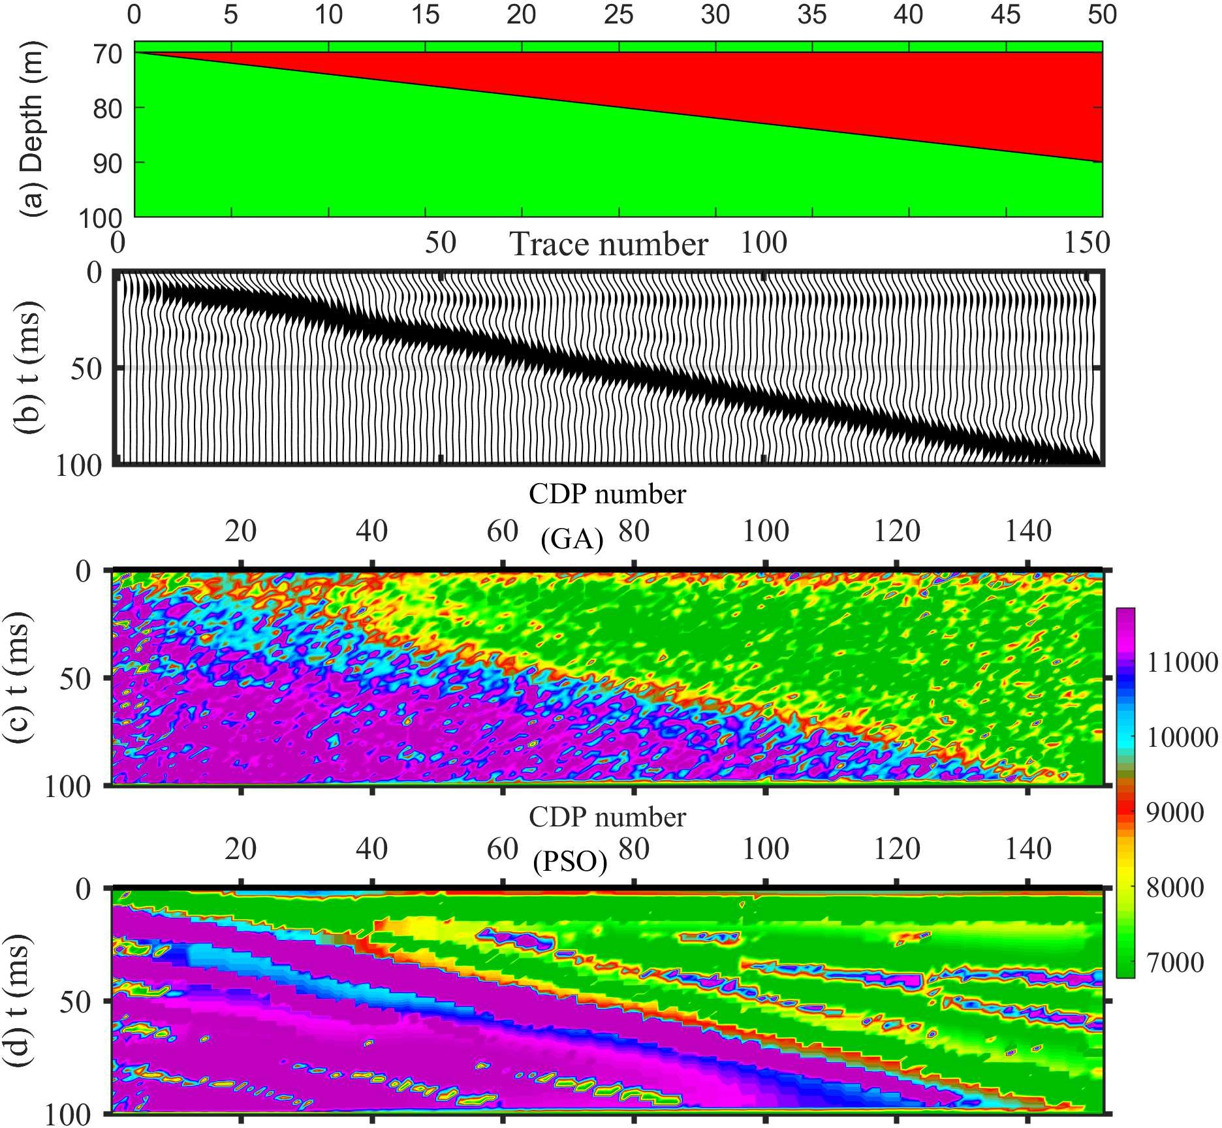

Figure 3. Represents a) a wedge model, b) synthetic data generated from the wedge model, c) inverted impedance from GA, and d) inverted impedance section from PSO.

Blackfoot data application
To predict the acoustic impedance and porosity in the inter-well zone, seismic data from the Blackfoot field in Canada is subjected to particle swarm optimization and the Genetic Algorithm. Although the entire volume of seismic data is accessible, only a cross-section at inline 1 and crosslines 1 to 50 are utilized to invert them by taking into account the long duration of convergence. Before performing inversion, first need to calculate the relationship between porosity reflectivity (R_{φ} ) and impedance reflectivity (R_{Z}), and the following formula is used.
1
R_{Z} = 2 [log(Z_{i+1}) − log(Z_{i})] (4)
1 − φ_{i}

R = 1 " log φi+1
φ
2
1 − φ_{i+1}

− log φi
# (5)

Where z_{i+1} and φ_{i+1} is (i+1)th layer impedance and porosity whereas, z_{i} and φ_{i} is the ith layer impedance and porosity respectively. These equations (4 and 5) are used to estimate the correlation factor (g) which is nothing but the slope of the fitted line. Figure 4a shows the cross plot of porosity reflectivity and acoustic reflectivity and the best-fit line gives a slope of
-0.14. This correlation factor is used to generate a porosity wavelet by multiplying the g factor with the impedance wavelet which is extracted directly from the seismic data. Figure 4b compares the porosity wavelet and the impedance wavelet and one can see that both are in reverse polarity and that porosity and impedance are inversely proportional to one another. The
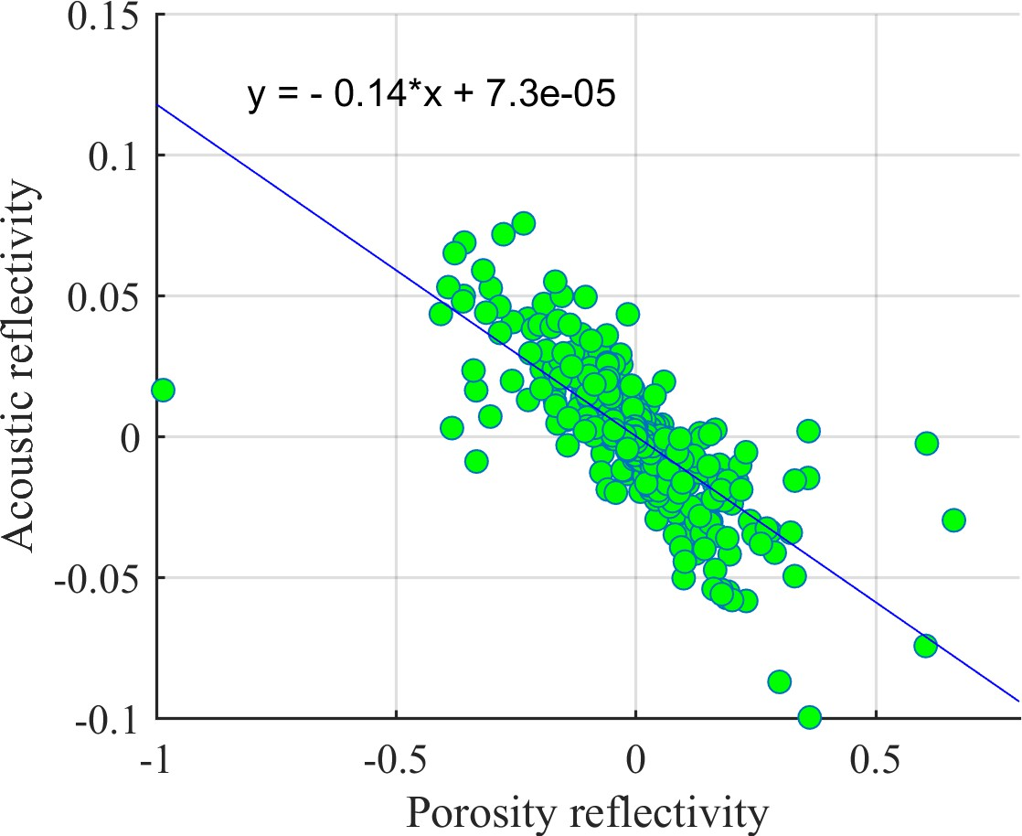
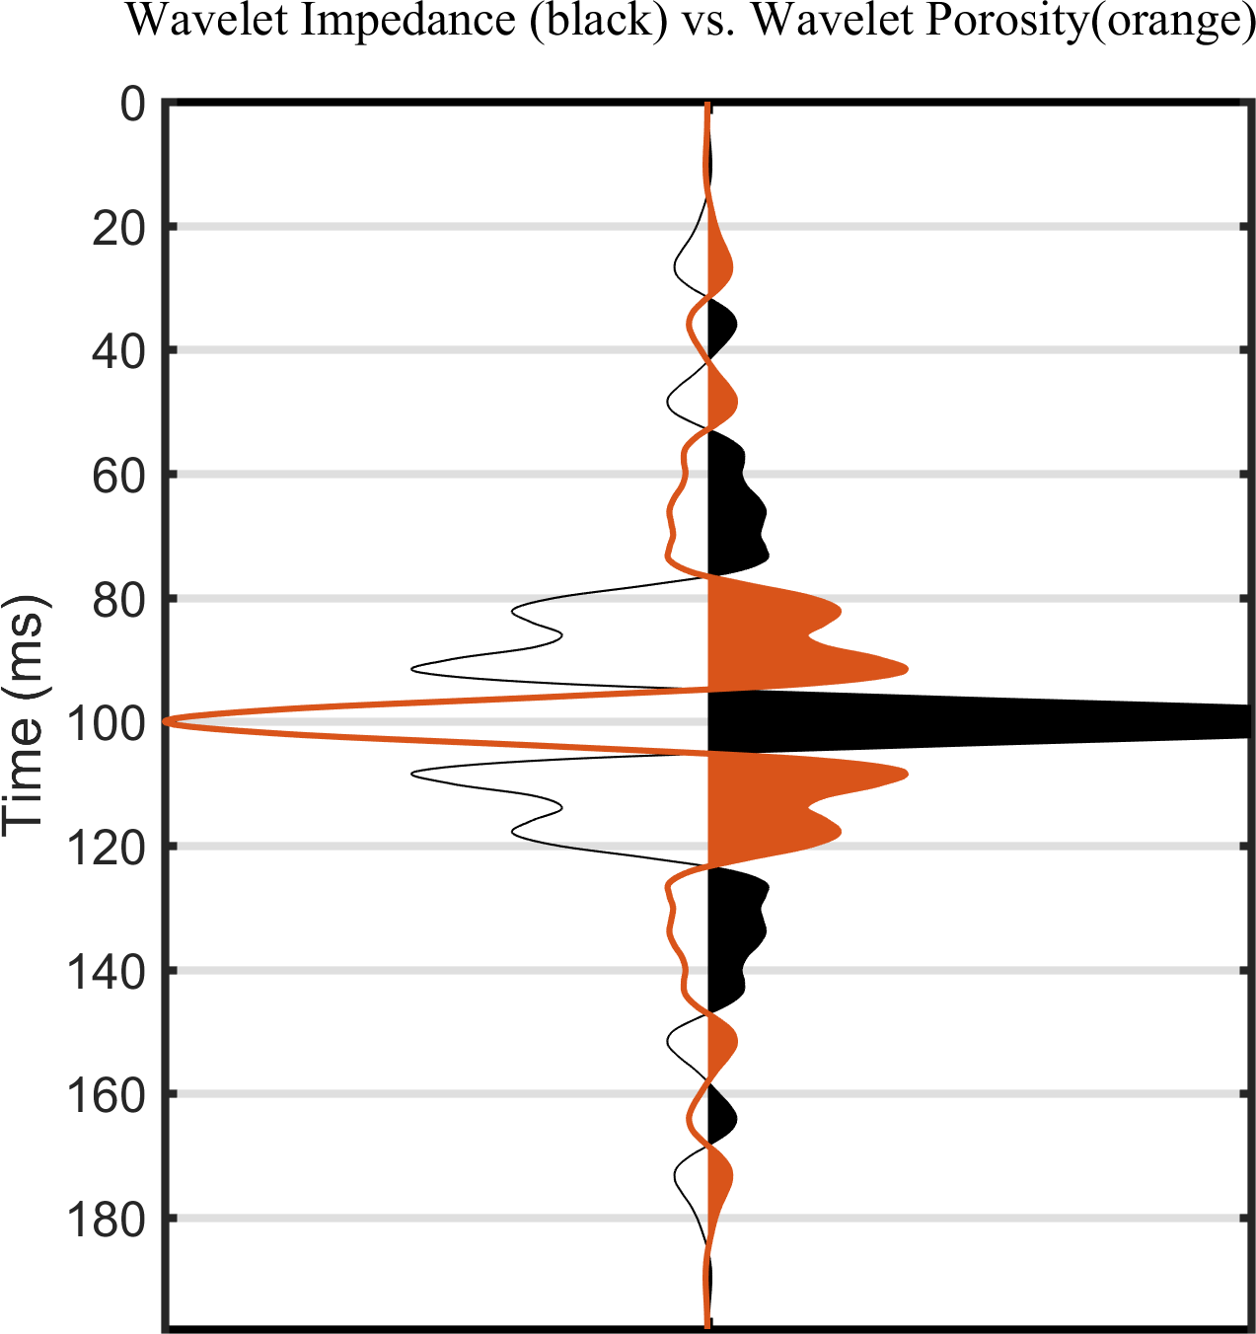
(a) (b)

Figure 4. (a) Crossplot between acoustic reflectivity and porosity reflectivity for well 01 − 08_logs is marked by a best linear trend which gives the correlation factor (g = −0.12), and (b) compares statistical wavelet (black) and porosity wavelet (red) generated by multiplication of correlation factor to the statistical wavelet.

application to real data is performed in two steps, first, a composite trace close to the well locations is derived from the seismic section, and both algorithms (GA and PSO) are applied to it. According to the theory, the composite trace is quite close to the well, and the same stratigraphy may be expected in the well as well as the composite trace. Both techniques explored begin with low-frequency acoustic impedance and porosity from the well-log and utilize it as a model to address constraints. The main advantage of beginning with a model based on well-log data is that it shortens the lengthy convergence process to these global optimization methods. In addition, a lover bound and an upper bound are used to further limit the search space inside the desired range. However, in our research, we used upper and lower bounds based on the original model built using well-log data. This range can be chosen from any possible value. Figure 5 depicts the inversion analysis result for the composite trace near wells 01-08, as calculated using the genetic algorithm and particle swarm optimization, respectively. Figure 5 depicts the original model (blue solid lines) as well as the lower and upper bounds (dotted blue lines). The first and second panels of Fig. 5 show a comparison of the original (black solid line) and inverted acoustic impedance (red solid line) whereas panels 3 and 4 compare the original (black solid line) and inverted porosity trace (red solid line). The AI and porosity created from well-defined data and inverted data have a good agreement with each other. The peak-to-peak of acoustic impedances and porosity do not match since well log data has a frequency range of 20 to 40 kHz, whereas seismic frequency typically ranges from 10 to 80 Hz. The correlation between well-log impedance and inverted impedance illustrated by GA and PSO is 0.71 and
0.66 and well-log porosity and inverted porosity are 0.63 and 0.63 respectively. Table 2 contains the other statistical comparison between well data and inverted data. According to the analysis, the inverted outcomes of PSO and GA are extremely near to the original, so the method performance is good. From the figure 5 we highlighted the target zone is between 1040 and to1065ms which shows low impedance and high porosity values from original as well as inverted data.
Thereafter, the global optimization techniques (GA and PSO) are applied trace by trace to the CDP stack section to determine the impedance and porosity volume. Figure 6a displays a cross-section at inline 1 and crosslines 1 to 50 with a two-way travel time of 900 − 1100ms of Blackfoot seismic data. Inversion is done trace by trace, and once all seismic traces have been inverted using GA and PSO, the results are plotted against two-way travel time and shown in Fig. 6b and 6c,
respectively. Figure 6b and 6c clearly shows that the 01-08 log impedance and inverted impedance have a good match and the low impedance zone is between 1040 and 1065ms. The boundary at 1040 ms is designated as a high reflecting layer because the high impedance layer (> 11000m/s ∗ g/cc) surrounds the low impedance zone (6500 − 8500m/s ∗ g/cc). The visual analysis depicts that the impedance estimated by the PSO methods has a higher resolution as compared with GA. The layers are more

Parameters | Well log  impedance | Inverted  impedance (GA) | Inverted  impedance (PSO) | Well-log  porosity | Inverted  porosity (GA) | Inverted  porosity (PSO)
Minimum | 6230 | 7600 | 6230 | -0.000580 | 0.006525 | 0.01645
Maximum | 13300 | 13130 | 13300 | 0.3898 | 0.3019 | 0.3105
Mean | 9536 | 9653 | 9536 | 0.1089 | 0.1609 | 0.1584
Median | 9600 | 9643 | 9600 | 0.08568 | 0.1945 | 0.191
Mode | 6230 | 7600 | 6230 | 0.06213 | 0.006525 | 0.01645
Std. deviation | 1299 | 1071 | 1299 | 0.07239 | 0.0927 | 0.1052
Range | 7071 | 5529 | 7071 | 0.904 | 0.2954 | 0.2941
Avg-CC | - | 0.72 | 0.66 | - | 0.63 | 0.63
Table 2. Statistics analysis of inverted impedance and porosity with well log impedance and porosity at well location 01 − 08_logs.
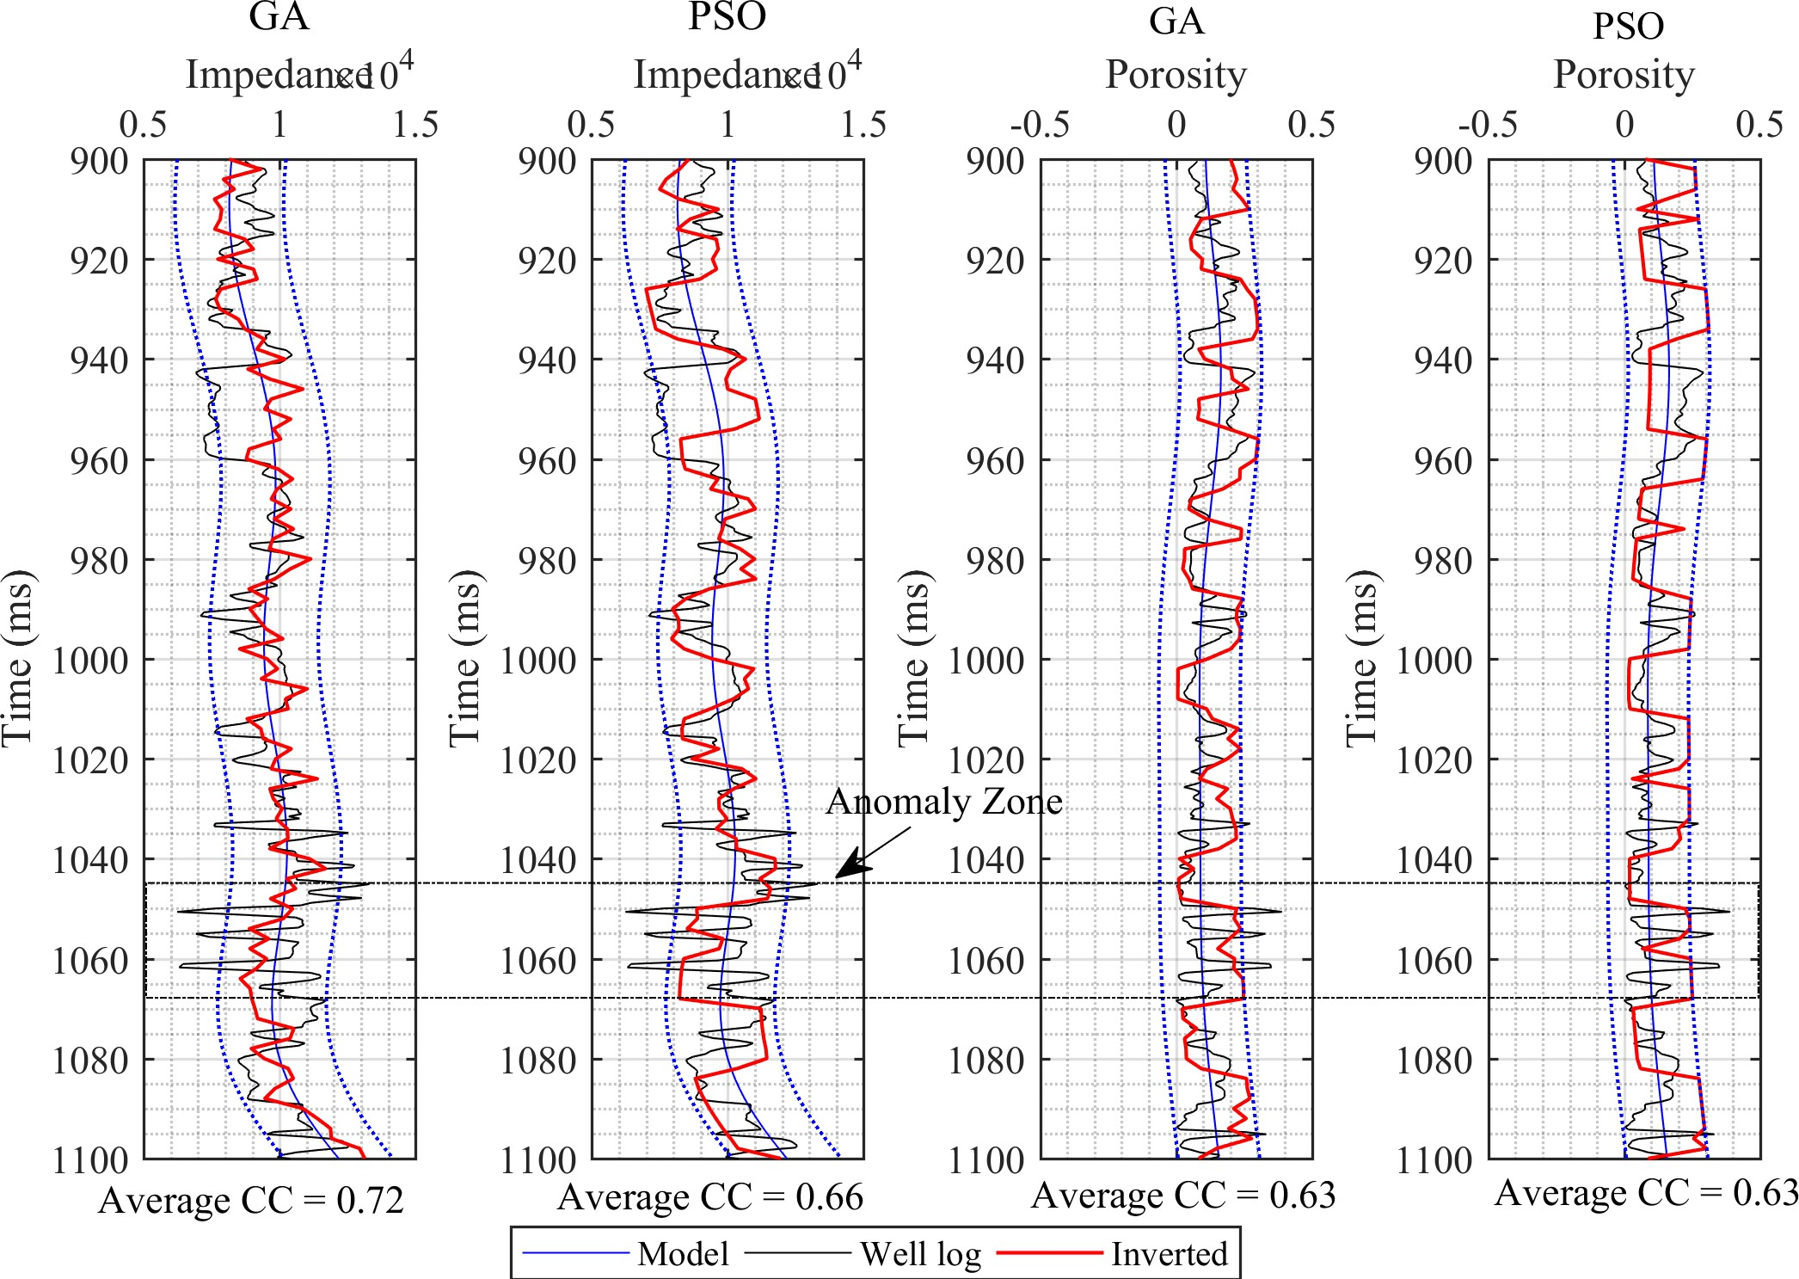
Figure 5. Represents four panels, the first and second panel compares inverted and well log impedance whereas the third and fourth panel compares inverted and well log porosity estimated from GA and PSO respectively.

clearly visible in PSO-derived impedance as compared with GA. Following that, Fig. 7 shows the porosity volume that was created by projecting porosity throughout the whole seismic section. Figure 7a depicts post-stack seismic data, Figs. 7b and 7c show the variation of the porosity section at inline 1 with a two-way travel time of 900-1100 milliseconds derived using GA and PSO techniques respectively. The inverted results show a very high resolution of the subsurface with layer information
whereas input seismic data only provides interface information. It is noted that the porosity varies from 1 to 30 percent in the study region and the high porosity zone (> 20%) is between 1040 and 1065ms two-way travel time. The well-log porosity also shows a very good agreement with inverted porosity in both cases (GA and PSO).
From the analysis of Fig. 6 and 7, one can notice that the low impedance zone found in the inverted impedance section also shows a very high porosity zone. This anomalous zone is already interpreted in the composite trace as well as well-log data in between 1040 to 1065ms two-way travel time. This anomalous zone is characterized as a reservoir (sand channel).
For the quality check, the inverted synthetic is generated from the inverted impedance and porosity using the forward

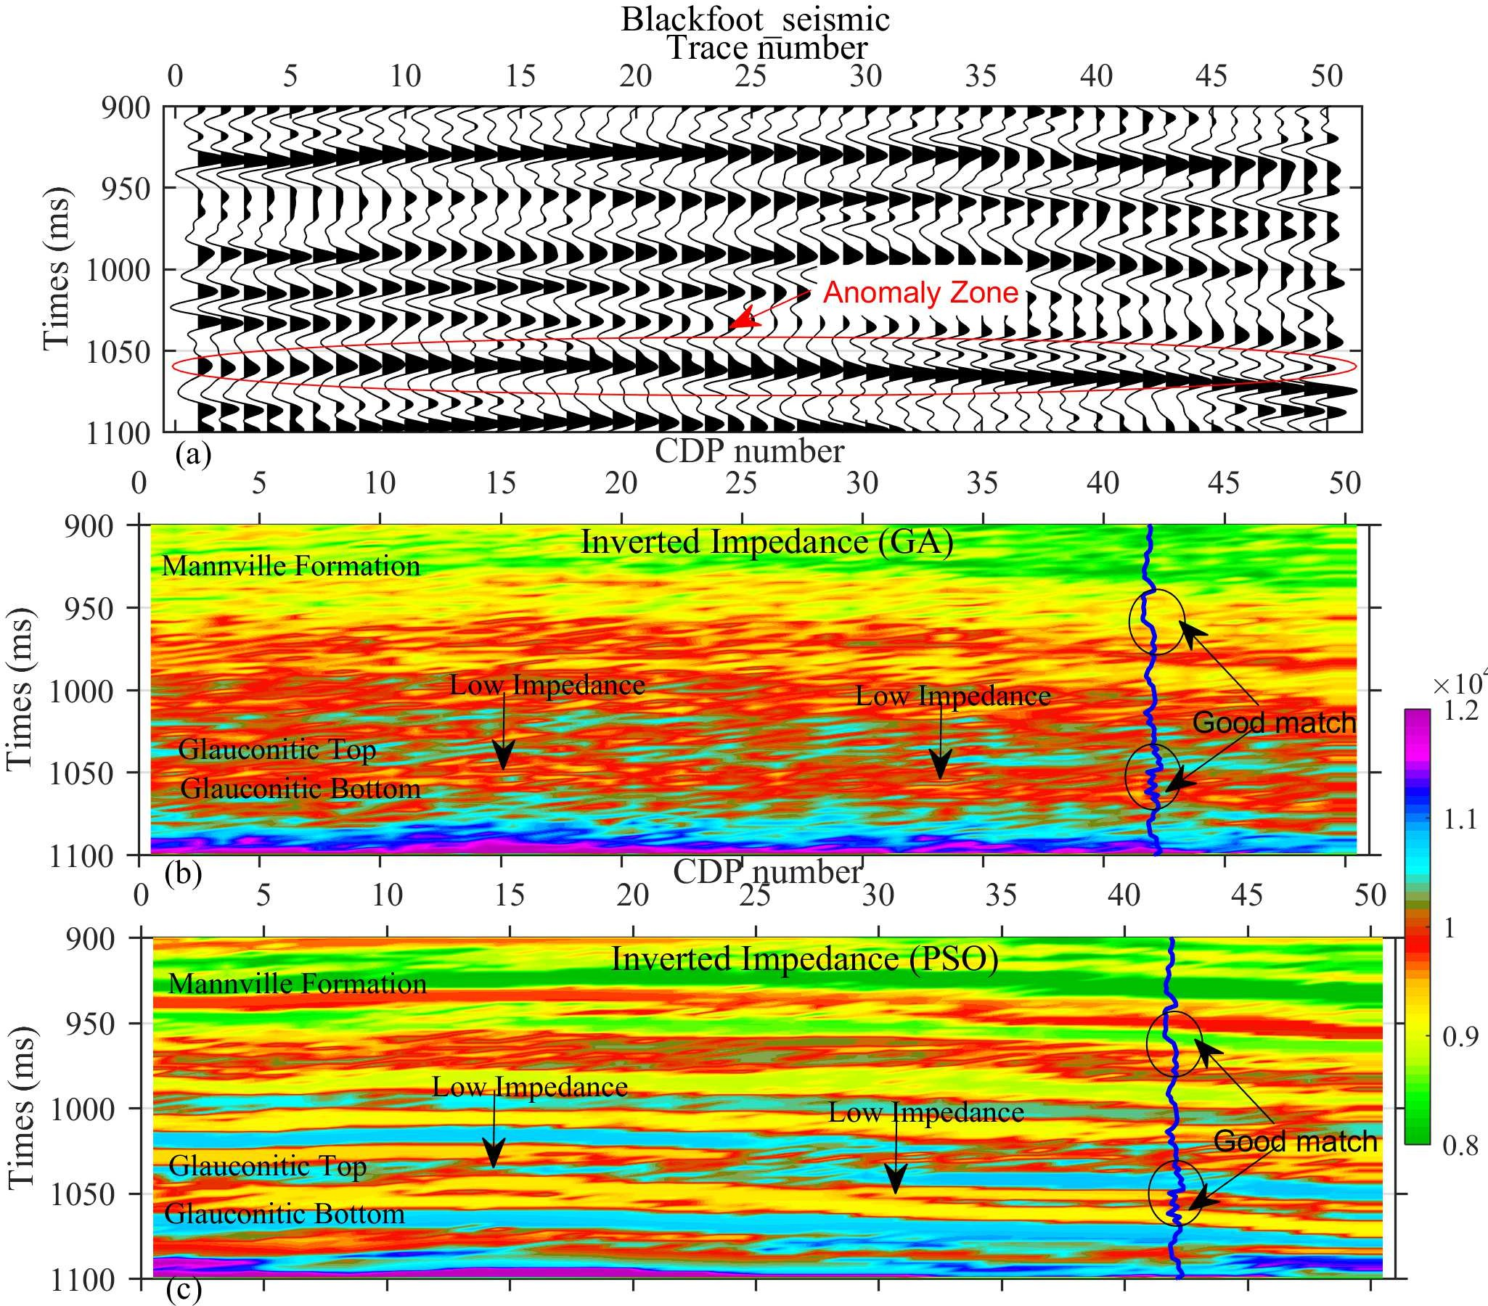
Figure 6. (a) shows input seismic section, (b) depicts inverted impedance section estimated from GA, and (c) shows inverted impedance section estimated using PSO.

modeling technique and compared with Blackfoot seismic data. Figure 8 compares and presents Blackfoot seismic and replicated synthetic data. Figure 8 is divided into 4 panels, the first compares Blackfoot seismic to replicated synthetic seismic generated by inverted impedance using a genetic algorithm whereas the second panel compared seismic and inverted synthetic estimated from particle swarm optimization. Both curves (in the case of GA and PSO), match with each other very well with
a very high correlation of 0.90 and 0.99, respectively. The third panel compares the seismic section with inverted synthetic derived from inverted porosity from GA and the fourth panel compares seismic data with inverted synthetic derived from the
porosity section estimated using the PSO technique. These two seismic sections (in the case of GA and PSO) match with each other very well and the correlation coefficient is estimated to be 0.87 and 0.92, respectively. These qualitative and quantitative evaluations demonstrate how well the algorithm performs in this scenario.
The GA and PSO optimization involves error minimization between observed (seismic) data and modeled (synthetic) data. The variation of error with iteration number is presented in Figure 9. The average error decreases from 1.0 to 0.8 when the genetic algorithm is used as a tool, whereas it reaches 0.3 when particle swarm optimization is used as a tool. From the figure, one can notice that the error decreases exponentially and major error decreases in between 1-100 iterations in both the cases
(GA and PSO). The analysis also shows that the error minimization is fast and the resolution of the inverted section estimated from PSO is better in comparison with GA.
The time required to perform the optimization procedure relies on the complexity of the geological model, the amount of data, and the algorithm utilized for seismic inversion. As a result, making optimal use of time, memory, and computer resources is critical to ensuring that the optimization process is completed in a fair amount of time. Fig. 10 compares the convergence time of the genetic algorithms and particle swarm optimization for synthetic as well as real data inversion cases.
From the figure, it can be noticed that the PSO is less time-consuming as compared with GA in both cases. Using a machine with 11th Gen Intel(R) Core(TM) i7 − 11700@2.50GHz 2.50GHz, the convergence time of GA is 670680sec. whereas the

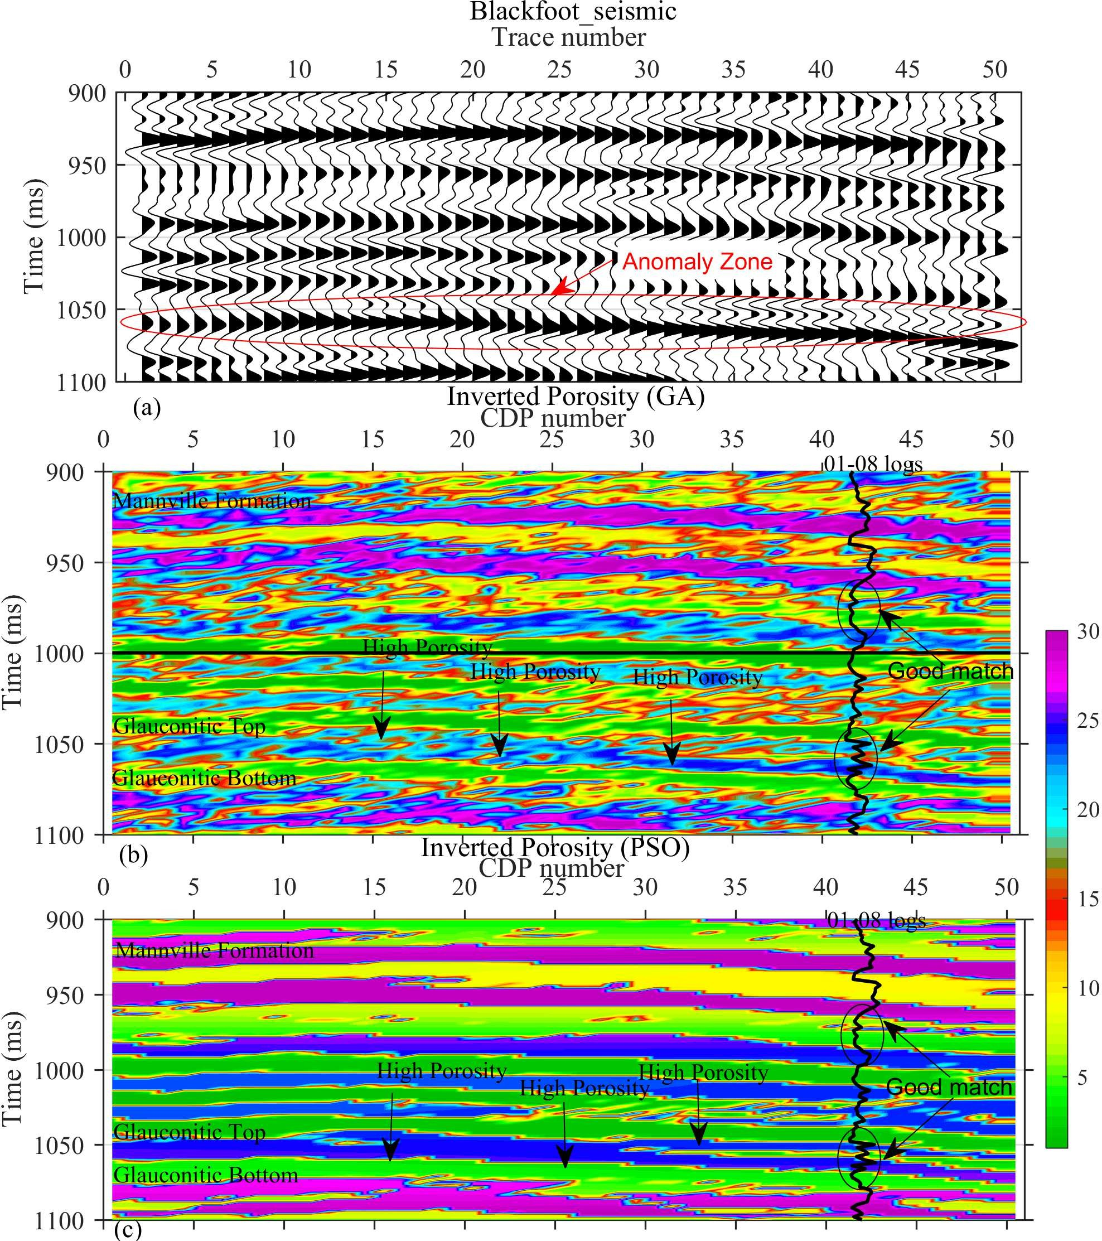

Figure 7. (a) Shows input seismic section, (b) depicts inverted porosity section estimated from GA, and (c) shows inverted porosity section estimated using PSO.

PSO takes 356400sec. to invert a total of 3240 traces. This indicates 88% less convergence time of PSO as compared with GA. This study’s anticipated impedance and porosity sections nearly match the expected values calculated by Maurya and Singh, 2018³ utilizing maximum likelihood sparse spike inversion and Probabilistic Neural Network, showing the usefulness of the technology used. Maurya and Singh (2018) estimated the acoustic impedance and porosity section. He also calculated an anomalous zone with a two-way travel time of 1040-1065ms and an extremely low acoustic impedance as well as a high porosity zone, which is likewise determined in the current investigation, and validated the results. Maurya and Singh, 2018 utilized the local optimization technique whereas the current study uses the global optimization technique is proven to be a very powerful tool to minimize error and produces very high-resolution subsurface information which can not retrieve using local
optimization techniques.

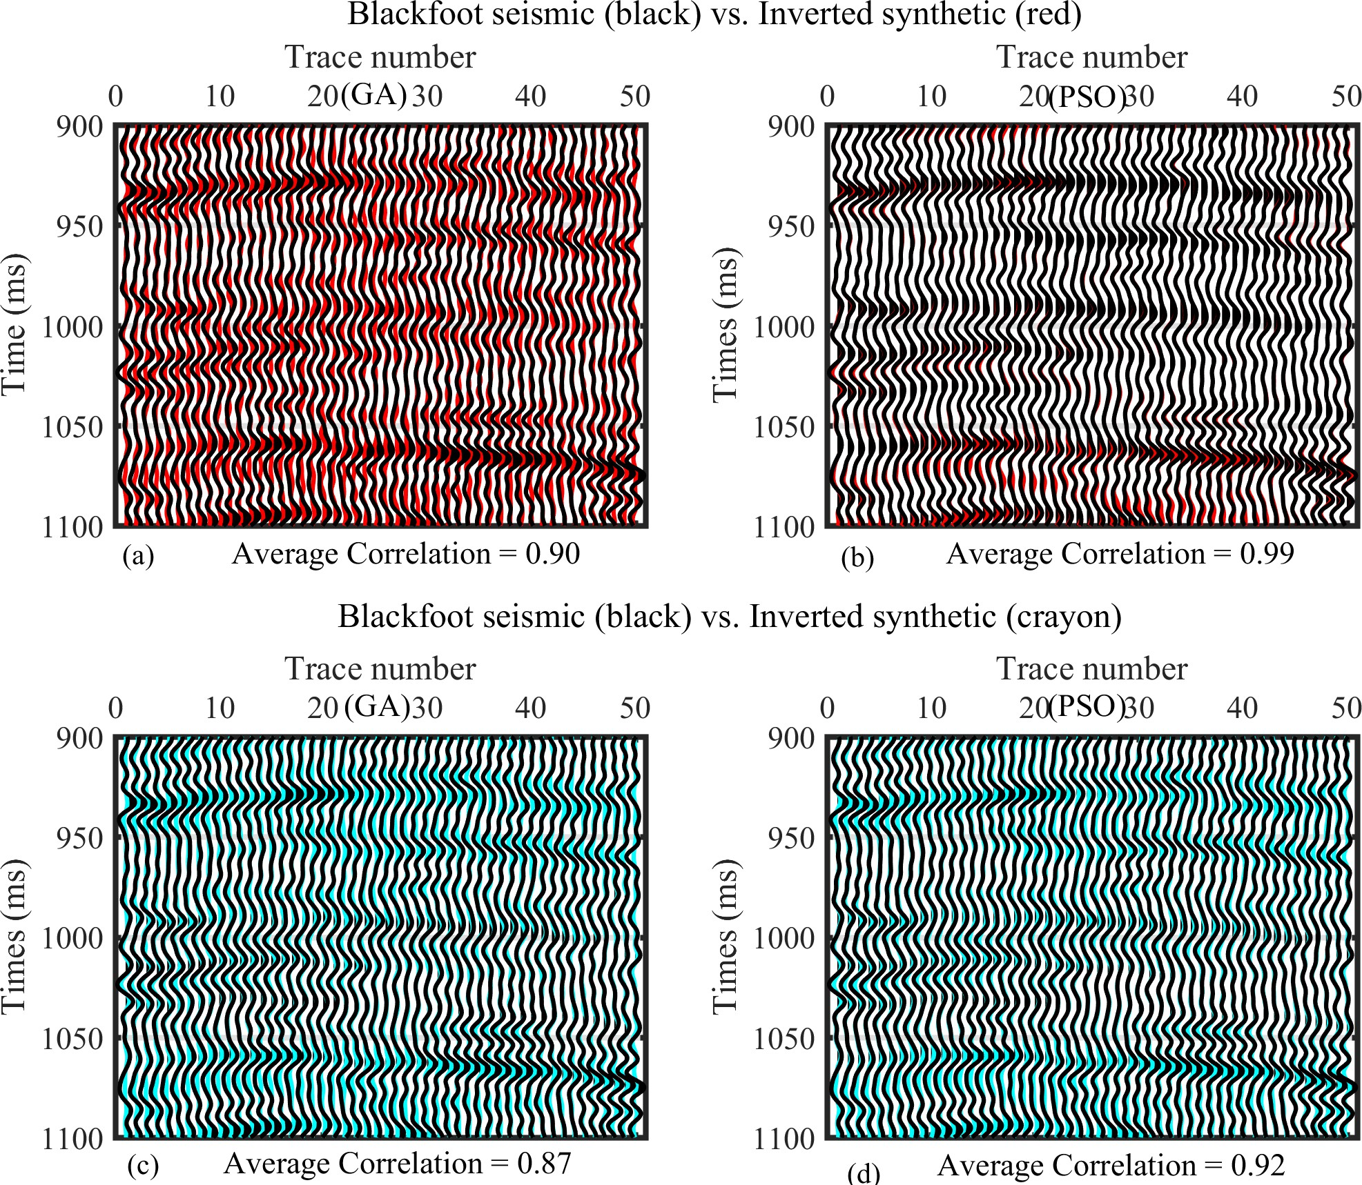
Figure 8. The first and second panel compares Blackfoot seismic and reproduced synthetic sections from the inverted impedance estimated using GA and PSO, respectively. The third and fourth panel compares Blackfoot seismic and reproduced synthetic sections from the inverted porosity estimated using GA and PSO, respectively.

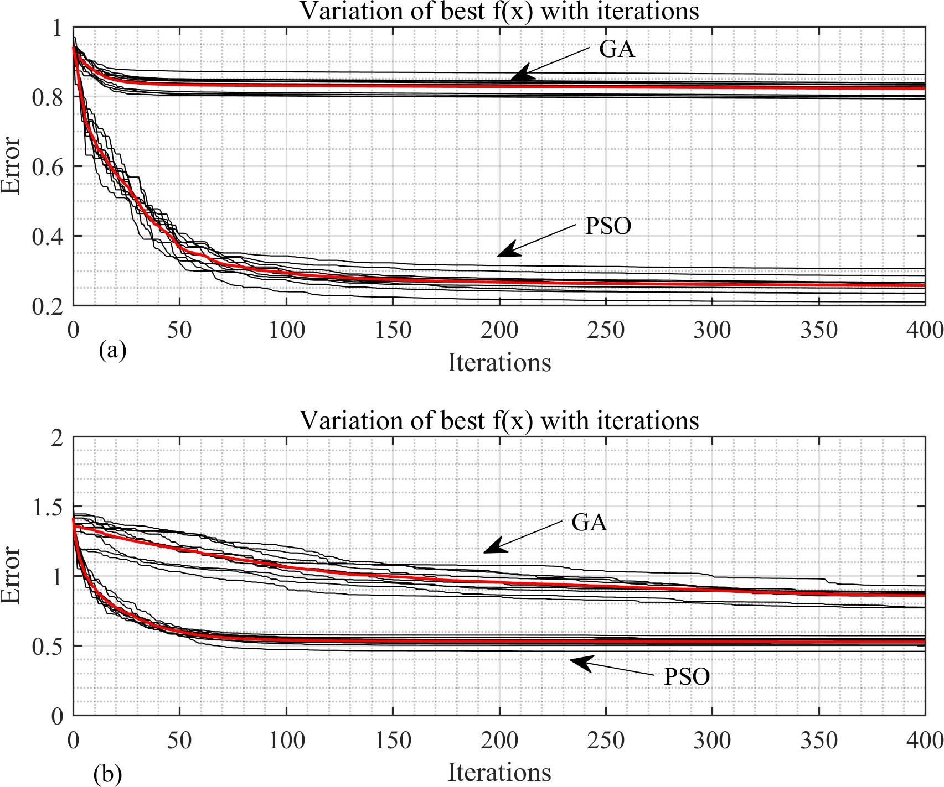
Figure 9. Variation of error with iteration estimated for the impedance inversion (top), and porosity inversion (bottom).

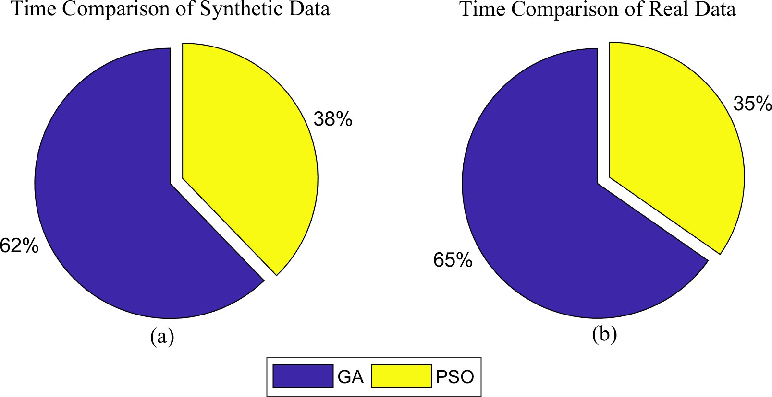
Figure 10. Convergence time comparison for (a) synthetic as well as (b) real data case.

Conclusions
Modeling and reservoir characterization is thought to be efficient ways to lower subsurface uncertainty and improve reservoir prediction accuracy. In the present study, qualitative as well as quantitative reservoir characterization has been performed using seismic inversion based on global optimization of genetic algorithm and particle swarm optimization. These two optimizations are not so common as they need high computing and expertise to implement but are very powerful tools to get very high-resolution subsurface information. The present study demonstrated that if prior information (well log) is included in these inversion methods, one can reduce convergence time and can generate very high-resolution subsurface information. A flowchart of seismic inversion based on PSO and GA has been developed in this study and tested with synthetic as well as real data. In synthetic data, the inverted impedance trace follows the trend of real impedance very well for GA and PSO-based inversion. The correlation coefficient is 0.993 and 0.986 have been achieved from GA and PSO inversion, respectively. The error variation with the iteration of particle swarm optimization is substantially lower than that of genetic algorithms. In real
data, the inverted impedance and porosity show very high-resolution subsurface information in both cases (GA and PSO), with impedance variation from 6000 − 16000m/s ∗ g/cc and porosity from 1 − 30%. The interpretation of inverted sections depicts a low impedance (6000 − 8500m/s ∗ g/cc) and high porosity (> 20%) anomaly in the time interval 1040-1065ms two-way travel time. This anomalous zone is also interpreted in well-log data and characterized as a reservoir (sand channel). The fitness
error in this inversion process decreases from 1 to 0.88 with GA optimization after 400 iterations as opposed to 1 to 0.25 using PSO. The convergence time for PSO optimization is 356400 seconds, but the convergence time for GA is 670680 seconds, demonstrating that the former takes 88% longer to reach convergence. The study suggests using PSO instead of GA in any E & P project since PSO inversion provides quicker convergence times, good error minimization, and high-resolution subsurface data in comparison to inversion utilizing GA optimization.

Acknowledgements
We thank GeoSoftware for providing Hampson Russell software, particularly Emerge, Strata, and Geoview. One of the authors, Dr. S.P. Maurya, expresses gratitude to the funding organizations UGC-BSR (M-14-0585) and IoE BHU (Dev. Scheme no. 6031B) for their financial assistance. In addition, we acknowledge the academic licenses for Matlab (2022b) and Norsar (full package), respectively, from www.mathworks.com and www.norsar.no respectively. This work couldn’t be done without their help.

Data availability
The data that support the findings of this study are available from https://www.geosoftware.com/ but restrictions apply to the availability of these data, which were used under license for the current study, and so are not publicly available. Data are however available from the author (S.P. Maurya) upon reasonable request and with permission from https://www.geosoftware.com/.

Author contributions statement
Ravi Kant developed the methodology and wrote the original draft of the manuscript, S.P. Maurya analysed the results and K.H. Singh supervised.

